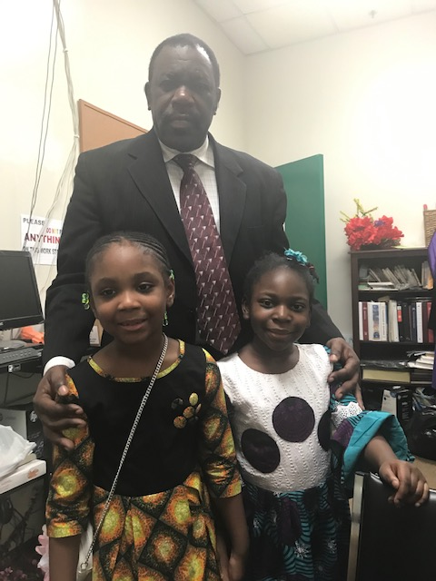
Taking picture with the kids
On their children’s day
2018

