UNIVERSIDAD DE MONTEMORELOS
Doctorado en Administración
Proyecto de Taller Metodológico III

Assignment with corrections
Name: Mark H. Brathwaite

- Describir en tablas y gráficos cinco variables métricas y cinco variables nominales.
In table 1, it is observed that the frequency of the gender of the participants is 47.6 percent for males and 52.4 percent for females.
Table 1 Gender of the participants
 |  | Frequency | Percent
 | Masculino | 60 | 47.6
 | Femenino | 66 | 52.4
 | Total | 126 | 100.0

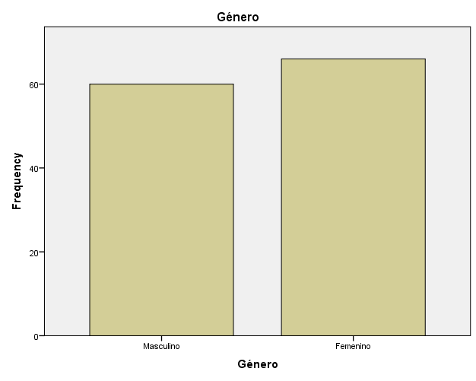

In table 2, it is observed that the civil status of the frequency of the participants indicates that 57.1 percent are soltero, 42.1 percent are casado while 0.8 percent are divorciado.

Table 2. Estado civil

 |  | Frequency | Percent
 | Soltero | 72 | 57.1
 | Casado | 53 | 42.1
 | Divorciado | 1 | .8
 | Total | 126 | 100.0
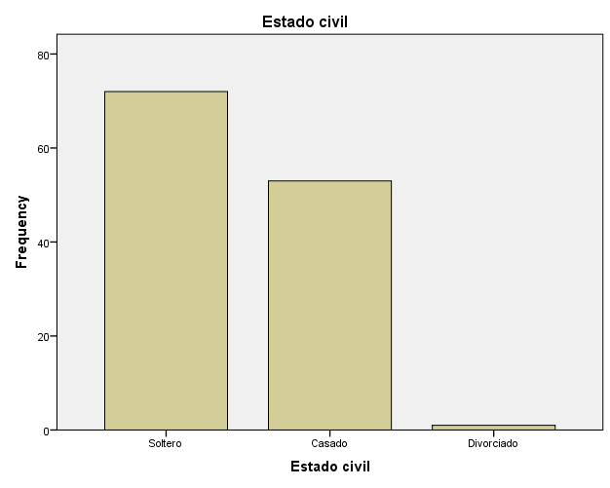

In table 3, it is observed that 97.6 percent of the participants responded yes to having a landline or cell phone, while 2.4 percent responded no to having a landline or cell phone.

Table 3. Landline or cell phone

 |  | Frequency | Percent
 | Si | 123 | 97.6
 | No | 3 | 2.4
 | Total | 126 | 100.0

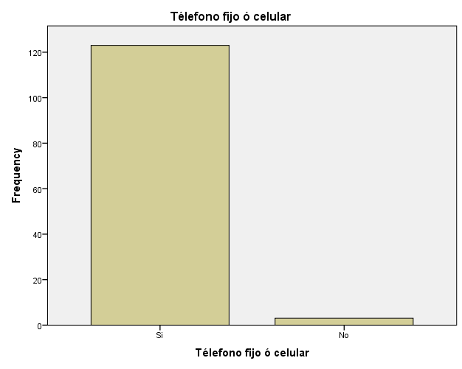
In table 4, it is observed the frequency of access to a computer of the participants responded yes is 87.3 percent, while 11.9 percent of the participants responded no to having access to a computer.

Table 4. Access to a computer

 |  | Frequency | Percent
 | SI | 110 | 87.3
 | No | 15 | 11.9
 | Total | 125 | 99.2
Missing | System | 1 | .8
Total |  | 126 | 100.0

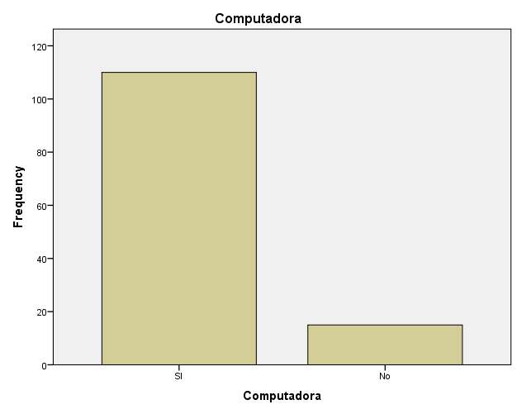
In table 5, it is observed the frequency of the participants indicated who indicated that 54.8 percent Rentade, propindad familiar, aun siesta paganda 15.1 percent, propiedad familiar 27.0 percent while prestada was 3.2 percent

 |  | Frequency | Percent
 | Rentada | 69 | 54.8
 | Propiedad familiar, aun se está pagando | 19 | 15.1
 | Propiedadfamiliar, pagada | 34 | 27.0
 | Prestada | 4 | 3.2
 | Total | 126 | 100.0
Table 5. La vivienda en la vives es
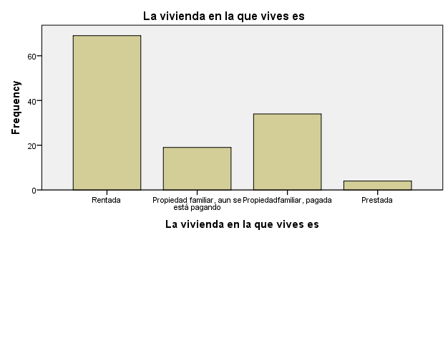

Cinco variables nominales

In Table 6. It is observed the frequency of the age of the participants that 93.1 percent of the age of the participants was recorded while 8.7 percent of the participants age is missing.

 |  | Frequency | Percent
 | 21 | 2 | 1.6
 | 22 | 7 | 5.6
 | 23 | 19 | 15.1
 | 24 | 12 | 9.5
 | 25 | 11 | 8.7
 | 26 | 9 | 7.1
 | 27 | 9 | 7.1
 | 28 | 4 | 3.2
 | 29 | 6 | 4.8
 | 30 | 11 | 8.7
 | 31 | 7 | 5.6
 | 32 | 5 | 4.0
 | 33 | 2 | 1.6
 | 34 | 1 | .8
 | 35 | 1 | .8
 | 36 | 1 | .8
 | 39 | 1 | .8
 | 41 | 1 | .8
 | 42 | 2 | 1.6
 | 44 | 3 | 2.4
 | 46 | 1 | .8
 | Total | 115 | 91.3
Missing | System | 11 | 8.7
Total |  | 126 | 100.0

Pie chart 1. Age of participants

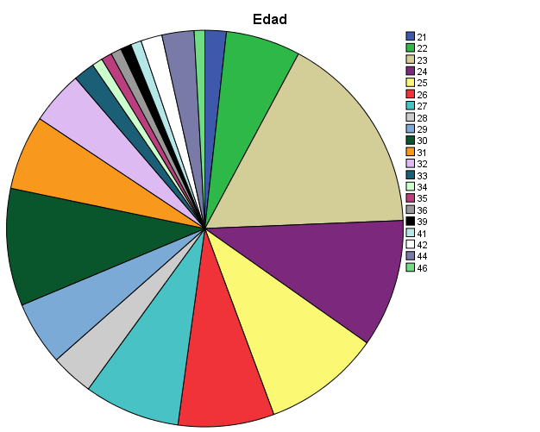

In Table 7. It is observed the frequency of Personas dependientes ti that 95.2 percent of the personas dependientes ti of the dependants was recorded, while 4.8 percent of the personas dependientes ti of the dependants was missing.

 |  | Frequency | Percent
 | 0 | 73 | 57.9
 | 1 | 21 | 16.7
 | 2 | 17 | 13.5
 | 3 | 7 | 5.6
 | 4 | 2 | 1.6
 | Total | 120 | 95.2
Missing | System | 6 | 4.8
Total |  | 126 | 100.0

Pie chart 2. Personas dependientes ti

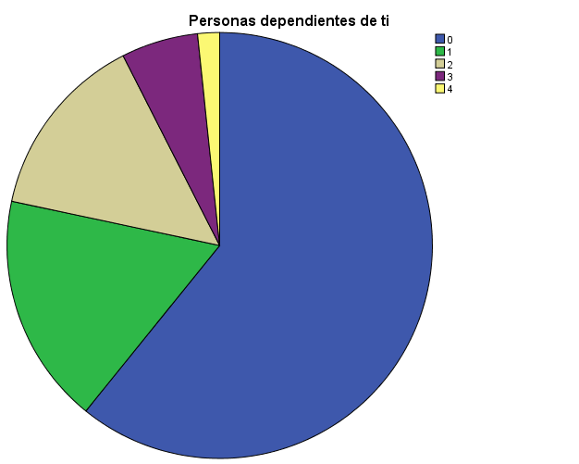

In Table 8. It is observed the frequency of MIembros que contribuyen al sostenimiento del hogar that 95.2 percent of MIembros que contribuyen al sostenimiento del hogar was recorded while 4.8 percent of MIembros que contribuyen al sostenimiento del hogar was missing.

 |  | Frequency | Percent
 | 1 | 41 | 32.5
 | 2 | 55 | 43.7
 | 3 | 18 | 14.3
 | 4 | 4 | 3.2
 | 5 | 1 | .8
 | 6 | 1 | .8
 | Total | 120 | 95.2
Missing | System | 6 | 4.8
Total |  | 126 | 100.0
Pie chart 3. MIembros que contribuyen al sostenimiento del hogar

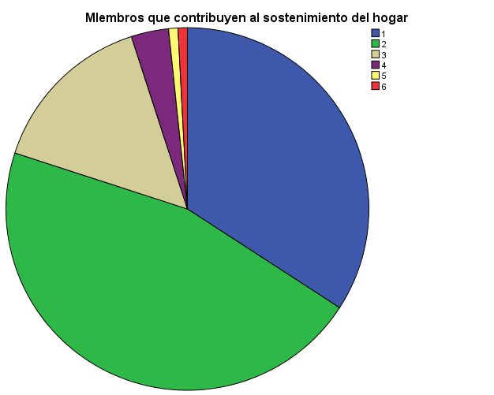

In Table 9. It is observed the frequency of Promedio de la licenciatura that 82.5 percent of Promedio de la licenciatura was recorded, while 17.5 percent of Promedio de la licenciatura was missing.
 |  | Frequency | Percent
 | 80 | 4 | 3.2
 | 82 | 1 | .8
 | 83 | 2 | 1.6
 | 84 | 1 | .8
 | 85 | 2 | 1.6
 | 86 | 2 | 1.6
 | 87 | 2 | 1.6
 | 88 | 2 | 1.6
 | 89 | 5 | 4.0
 | 90 | 10 | 7.9
 | 91 | 6 | 4.8
 | 92 | 13 | 10.3
 | 93 | 6 | 4.8
 | 94 | 14 | 11.1
 | 95 | 11 | 8.7
 | 96 | 2 | 1.6
 | 97 | 8 | 6.3
 | 98 | 7 | 5.6
 | 99 | 6 | 4.8
 | Total | 104 | 82.5
Missing | System | 22 | 17.5
Total |  | 126 | 100.0

Pie chart 4. Promedio de la licenciatura
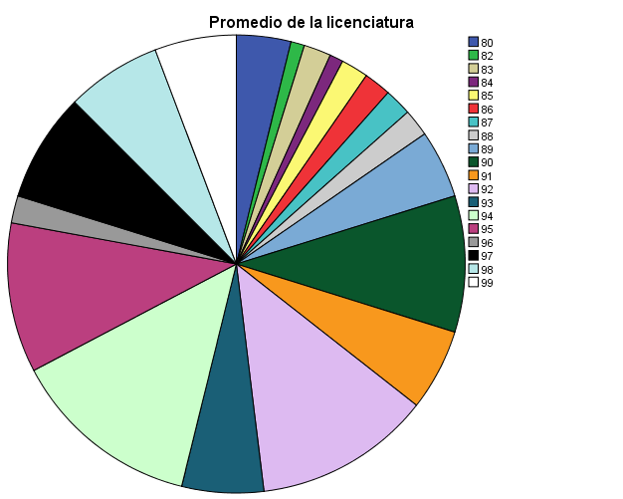

In Table 10. It is observed the frequency of the Número de horas promedio laboradas en la semana was 65.1 percent, while 34.9 percent of Número de horas promedio laboradas en la semana was missing.

 |  | Frequency | Percent
 | 5 | 1 | .8
 | 6 | 1 | .8
 | 8 | 1 | .8
 | 10 | 1 | .8
 | 14 | 1 | .8
 | 15 | 1 | .8
 | 19 | 1 | .8
 | 20 | 12 | 9.5
 | 24 | 1 | .8
 | 25 | 13 | 10.3
 | 27 | 1 | .8
 | 28 | 1 | .8
 | 30 | 16 | 12.7
 | 31 | 1 | .8
 | 32 | 2 | 1.6
 | 35 | 3 | 2.4
 | 36 | 2 | 1.6
 | 38 | 1 | .8
 | 40 | 13 | 10.3
 | 42 | 2 | 1.6
 | 45 | 1 | .8
 | 48 | 1 | .8
 | 49 | 1 | .8
 | 50 | 1 | .8
 | 52 | 1 | .8
 | 59 | 1 | .8
 | 72 | 1 | .8
 | Total | 82 | 65.1
Missing | System | 44 | 34.9
Total |  | 126 | 100.0

Pie chart 5. Número de horas promedio laboradas en la semana
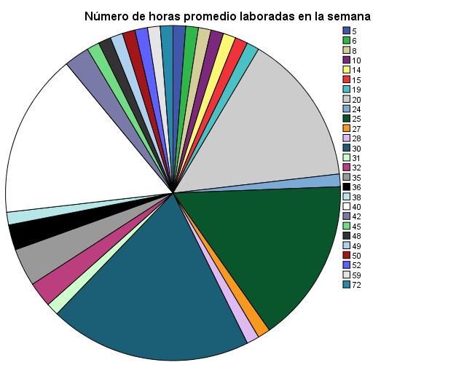

2. Elaborar cuatro tablas cruzadas.
In Table11. We can observe how males are soltero, Casado and Divorciado. Also we can observe how females are soltero, Casado and Divorciado.

Table 6

Género * Estado civil Crosstabulation
 |  |  | Estado civil |  |  | Total
 |  |  | Soltero | Casado | Divorciado | Total
Género | Masculino | Count | 33 | 27 | 0 | 60
Género | Masculino | % within Género | 55.0% | 45.0% | 0.0% | 100.0%
Género | Femenino | Count | 39 | 26 | 1 | 66
Género | Femenino | % within Género | 59.1% | 39.4% | 1.5% | 100.0%
Total |  | Count | 72 | 53 | 1 | 126
 |  | % within Género | 57.1% | 42.1% | 0.8% | 100.0%

Observations:
For the males, the table reveals that 33 males accounting for 55% are soltero, while 27 males accounting for 45% are casado and none are divorciado 0%.

Fort the females, the table reveals that 39 females accounting for 59.1% are soltero, while 26 females accounting for 39.4% are casado and 1 is divorciado accounting for 1.5%.

In Table 12. We can observe how males rentada, propiedad familiar aun se esta pagando, Propiedadfamiliar, pagada, prestada.
Table 12
Género * La vivienda en la que vives es Crosstabulation
 |  |  | La vivienda en la que vives es |  |  |  | Total
 |  |  | Rentada | Propiedad familiar, aun se está pagando | Propiedadfamiliar, pagada | Prestada | Total
Género | Masculino | Count | 32 | 9 | 16 | 3 | 60
Género | Masculino | % within Género | 53.3% | 15.0% | 26.7% | 5.0% | 100.0%
Género | Femenino | Count | 37 | 10 | 18 | 1 | 66
Género | Femenino | % within Género | 56.1% | 15.2% | 27.3% | 1.5% | 100.0%
Total |  | Count | 69 | 19 | 34 | 4 | 126
 |  | % within Género | 54.8% | 15.1% | 27.0% | 3.2% | 100.0%
Observations:
For the males, the table reveals that 32 males accounting for 53.3% are rentada, while 9 males accounting for 15% are propiedad familiar, aun se está pagando, while 16 males accounting for 26.7% are propiedad familiar, pagada and 3 males accounting for 5% are prestada.

For the females, the table reveals that 37 females accounting for 56.1% are rentada, while 10 females accounting for 15.2% are propiedad familiar, aun se está pagando, while 18 females accounting for 27.3% are propiedad familiar, pagada and 1 female accounting for 1.5% is prestada

In Table 13. We can observe how many males have Télefono fijo ó cellular and how many females have Télefono fijo ó cellularalong with percentages.
Table13
Género * Télefono fijo ó celular Crosstabulation
 |  |  | Télefono fijo ó celular |  | Total
 |  |  | Si | No | Total
Género | Masculino | Count | 60 | 0 | 60
Género | Masculino | % within Género | 100.0% | 0.0% | 100.0%
Género | Femenino | Count | 63 | 3 | 66
Género | Femenino | % within Género | 95.5% | 4.5% | 100.0%
Total |  | Count | 123 | 3 | 126
 |  | % within Género | 97.6% | 2.4% | 100.0%

Observations:
For the males, the table reveals that 60 males accounting for 100% responded si to télefono fijo ó celular while 63 females accounting for 95.5% responded, Si to télefono fijo ó celular and 3 females responded 4.5% responded No to télefono fijo ó cellular.

In Table 14. We can observehow many males have computadora and how many females have computadora along with the percentages.

Table14
Género * Computadora Crosstabulation
 |  |  | Computadora |  | Total
 |  |  | SI | No | Total
Género | Masculino | Count | 53 | 6 | 59
Género | Masculino | % within Género | 89.8% | 10.2% | 100.0%
Género | Femenino | Count | 57 | 9 | 66
Género | Femenino | % within Género | 86.4% | 13.6% | 100.0%
Total |  | Count | 110 | 15 | 125
 |  | % within Género | 88.0% | 12.0% | 100.0%

Observations:
For the males, the table reveals that 53 males accounting for 89.8% responded Si to computadora while 6 males accounting for 10.2% responded, No to computadora while 57 females accounting for 86.4% responded Si and 9 females accounting for 13.6% responded No to computadora.

3. Hacer tres ejemplos de correlación.
Example 1
H₀ There is no significant relation between Con1 and Con2
H₁ There is a significant correlation between Con1 and Con2
In the table below the df = 111 and the significant level = .200 which indicate a normality.
Tests of Normality
 | Kolmogorov-Smirnovª |  |  | Shapiro-Wilk
 | Statistic | df | Sig. | Statistic | df | Sig.
con1 | .049 | 111 | .200* | .986 | 111 | .309
con2 | .066 | 111 | .200* | .985 | 111 | .228
*. This is a lower bound of the true significance.
a. Lilliefors Significance Correction

Using the Correlation of Pearson, it was found that the correlation between Con1 and Con2 the relation is .291 with a p of 0.01 which means that there is a relation between con1 and con2. Therefore, we reject the known hypothesis which says that there is no correlation between the two variables.

Correlations
 |  | con1 | con2
con1 | Pearson Correlation | 1 | .291**
con1 | Sig. (2-tailed) |  | .002
con1 | N | 118 | 111
con2 | Pearson Correlation | .291** | 1
con2 | Sig. (2-tailed) | .002
con2 | N | 111 | 111
**. Correlation is significant at the 0.01 level (2-tailed).
Example 2

H₀ There is no significant relation between hab1 and hab2
H₁ There is a significant correlation between hab1 and hab2
In the table below the df = 114 and the significant level = .029 which requires the Pearson correlation test.

Tests of Normality
 | Kolmogorov-Smirnovª |  |  | Shapiro-Wilk
 | Statistic | Df | Sig. | Statistic | df | Sig.
hab1 | .081 | 114 | .066 | .975 | 114 | .029
hab2 | .096 | 114 | .012 | .944 | 114 | .000
a. Lilliefors Significance Correction

Using the Correlation of Pearson, it was found that the correlation between hab1 and hab2 the relation is .191 with a p of 0.05 which means that there is a relation between hab1 and hab2. Therefore, we reject the known hypothesis which says that there is no correlation between the two variables.

Correlations
 |  | hab1 | hab2
hab1 | Pearson Correlation | 1 | .191*
hab1 | Sig. (2-tailed) |  | .042
hab1 | N | 120 | 114
hab2 | Pearson Correlation | .191* | 1
hab2 | Sig. (2-tailed) | .042
hab2 | N | 114 | 115
*. Correlation is significant at the 0.05 level (2-tailed).
Example 3
H₀ There is not a significant relation between Satisunav and Satisdesemp
H₁ There is a significant correlation between Satisunav and Satisdesemp
In the table below the df = 110 and the significant level = .254 which requires the Pearson correlation test.

Tests of Normality
 | Kolmogorov-Smirnovª |  |  | Shapiro-Wilk
 | Statistic | df | Sig. | Statistic | df | Sig.
satisunav | .047 | 110 | .200* | .985 | 110 | .254
satisdesemp | .083 | 110 | .062 | .979 | 110 | .084
*. This is a lower bound of the true significance.
a. Lilliefors Significance Correction

Using the Correlation of Pearson, it was found that the correlation between Satisunav and Satisdesemp the relation is .228 with a p of 0.05 which means that there is a relation between Satisunav and Satisdesemp. Therefore, we reject the known hypothesis which says that there is no correlation between the two variables.

Correlations
 |  | satisunav | satisdesemp
satisunav | Pearson Correlation | 1 | .228*
satisunav | Sig. (2-tailed) |  | .017
satisunav | N | 115 | 110
satisdesemp | Pearson Correlation | .228* | 1
satisdesemp | Sig. (2-tailed) | .017
satisdesemp | N | 110 | 117
*. Correlation is significant at the 0.05 level (2-tailed).

4. Formar tres rectas de regresión simple.
Example 1
H₀ knowledge (con1) is not a predictor of skills (hab1).
H₁ Knowledge is (con1) a significant predictor of skills.
The value of R² adjusted was equal to .571 which means that this variable explains 57.1% of variance of the dependent variable. F value equal to 154.264 and p value equal to .000. as it can be observed that the p value is less than .05, therefore there is a positive and significant lineal correlation. Thus, the null hypothesis is rejected.
This is the equation B₀ equal to .510 and B₁ equal to .842

Model Summary^{b}
Model | R | R Square | Adjusted R Square | Std. Error of the Estimate
1 | .758ª | .575 | .571 | .31028
a. Predictors: (Constant), con1
b. Dependent Variable: hab1

ANOVAª
Model |  | Sum of Squares | df | Mean Square | F | Sig.
1 | Regression | 14.851 | 1 | 14.851 | 154.264 | .000^{b}
1 | Residual | 10.975 | 114 | .096
1 | Total | 25.826 | 115
a. Dependent Variable: hab1
b. Predictors: (Constant), con1

Coefficientsª
Model |  | Unstandardized Coefficients |  | Standardized Coefficients | t | Sig.
 |  | B | Std. Error | Beta | t | Sig.
1 | (Constant) | .510 | .221 |  | 2.305 | .023
1 | con1 | .842 | .068 | .758 | 12.420 | .000
a. Dependent Variable: hab1

Example 2
H_{0 –} Satifaction (asatisunav) is not s significant predictor of skills (hab1).
H_{1 –} Satifaction (asatisunav) is a significant predictor of skills (hab1).
The value of R² adjusted was equal to .359 which means that this variable explains 35.9 % of variance of the dependent variable. F value equal to 64.347 and p value equal to .000. as it can be observed that the p value is less than .05, therefore there is a positive and significant lineal correlation. Thus, the null hypothesis is rejected.
This is the equation B₀ equal to 1.291 and B₁ equal to .017

Model Summary^{b}
Model | R | R Square | Adjusted R Square | Std. Error of the Estimate
1 | .604ª | .365 | .359 | .38098
a. Predictors: (Constant), satisunav
b. Dependent Variable: hab1

ANOVAª
Model |  | Sum of Squares | df | Mean Square | F | Sig.
1 | Regression | 9.340 | 1 | 9.340 | 64.347 | .000^{b}
1 | Residual | 16.256 | 112 | .145
1 | Total | 25.596 | 113
a. Dependent Variable: hab1
b. Predictors: (Constant), satisunav

Coefficientsª
Model |  | Unstandardized Coefficients |  | Standardized Coefficients | t | Sig.
 |  | B | Std. Error | Beta | t | Sig.
1 | (Constant) | 1.291 | .245 |  | 5.269 | .000
1 | satisunav | .017 | .002 | .604 | 8.022 | .000
a. Dependent Variable: hab1

Example 3
H₀ knowledge (con1) is not a predictor of Satisfaction (satisunav).
H₁ Knowledge (con 1) is a significant predictor of Satisfaction (satisunav).
The value of R² adjusted was equal to .269 which means that this variable explains 26.9 % of variance of the dependent variable. F value equal to 41.415 and p value equal to .000. as it can be observed that the p value is less than .05, therefore there is a positive and significant lineal correlation. Thus, the null hypothesis is rejected.
This is the equation B₀ equal to 48.056 and B₁ equal to 20.763

Model Summary^{b}
Model | R | R Square | Adjusted R Square | Std. Error of the Estimate
1 | .525ª | .275 | .269 | 14.61969
a. Predictors: (Constant), con1
b. Dependent Variable: satisunav

ANOVAª
Model |  | Sum of Squares | df | Mean Square | F | Sig.
1 | Regression | 8851.788 | 1 | 8851.788 | 41.415 | .000^{b}
1 | Residual | 23297.149 | 109 | 213.735
1 | Total | 32148.937 | 110
a. Dependent Variable: satisunav
b. Predictors: (Constant), con1

Coefficientsª
Model |  | Unstandardized Coefficients |  | Standardized Coefficients | t | Sig.
 |  | B | Std. Error | Beta | t | Sig.
1 | (Constant) | 48.056 | 10.533 |  | 4.562 | .000
1 | con1 | 20.763 | 3.226 | .525 | 6.435 | .000
a. Dependent Variable: satisunav

5. Elaborar dos ejemplos de regresión múltiple formado por los siguientes constructos: (a) conocimientos 1 – Habilidades 1 – Actitudes 1 como predictores de la satisfacción con la UNAV, (b) Conocimientos 2 – habilidades 2 – actitudes 2 como predictores de desempeño profesional.

Example 1
Model Summary
Model | R | R Square | Adjusted R Square | Std. Error of the Estimate
1 | .633ª | .400 | .383 | 13.38070
a. Predictors: (Constant), hab1, con1, act1

ANOVAª
Model |  | Sum of Squares | df | Mean Square | F | Sig.
1 | Regression | 12537.162 | 3 | 4179.054 | 23.341 | .000^{b}
1 | Residual | 18799.517 | 105 | 179.043
1 | Total | 31336.679 | 108
a. Dependent Variable: satisunav
b. Predictors: (Constant), hab1, con1, act1

H₀ - con1, act1 and hab1 are not predictors of satisfaction with the UNAV
The value of R² adjusted was equal to .383, which means that these three variables explain 38.3% of the variance of the dependent variable Satisfaction UNAV. F value equal to 23.341 and P value equal .000. As it can be observed that the P value is less than .05, therefore, there is a positive and significant lineal correlation. Thus, the null hypothesis is rejected.
This is the equation B₀ equal to 27.421, B₁ equal to 8.72, B₂ equal to 10.626, B₃ equal to 6.362.

Coefficientsª
Model |  | Unstandardized Coefficients |  | Standardized Coefficients | t | Sig.
 |  | B | Std. Error | Beta | t | Sig.
1 | (Constant) | 27.421 | 11.295 |  | 2.428 | .017
1 | act1 | 10.626 | 4.813 | .288 | 2.208 | .029
1 | con1 | 6.352 | 4.601 | .161 | 1.381 | .170
1 | hab1 | 8.721 | 5.714 | .243 | 1.526 | .130
a. Dependent Variable: satisunav

Example 2

Model Summary
Model | R | R Square | Adjusted R Square | Std. Error of the Estimate
1 | .365ª | .133 | .107 | 5.27001
a. Predictors: (Constant), hab2, con2, act2

ANOVAª
Model |  | Sum of Squares | df | Mean Square | F | Sig.
1 | Regression | 430.487 | 3 | 143.496 | 5.167 | .002^{b}
1 | Residual | 2805.074 | 101 | 27.773
1 | Total | 3235.562 | 104
a. Dependent Variable: satisdesemp
b. Predictors: (Constant), hab2, con2, act2
H_{o –} con 2, act 2, and hab2 are not predictors of professional performance.
The value of R² adjusted was equal to .107 which means that the three variables explain 10 % of the variance of the independent variable satisfaction UNAV. The F value equals to 5.167 and the P value equals to .002. As it can be observed that the P value is less than .05. Therefore, this is a positive and significant correlation. Thus, the null hypothesis is rejected..
This is the equation B_{o} equal to 4.025, B₁ equal to -1.809, B₂ equal to 3.462 and B₃ equal to 4.207

Coefficientsª
Model |  | Unstandardized Coefficients |  | Standardized Coefficients | t | Sig.
 |  | B | Std. Error | Beta | t | Sig.
1 | (Constant) | 4.025 | 6.261 |  | .643 | .522
1 | con2 | -1.809 | 1.297 | -.174 | -1.395 | .166
1 | act2 | 4.207 | 2.316 | .240 | 1.816 | .072
1 | hab2 | 3.462 | 2.072 | .250 | 1.671 | .098
a. Dependent Variable: satisdesemp

6. Tres ejemplos de prueba t para muestras independientes.
Example 1
H₀ There is no difference of perception between gender and satisfaction with the UNAV.

Tests of Normality
 | Género | Kolmogorov-Smirnovª |  |  | Shapiro-Wilk
 | Género | Statistic | df | Sig. | Statistic | df | Sig.
satisunav | Masculino | .103 | 57 | .200* | .972 | 57 | .203
satisunav | Femenino | .088 | 58 | .200* | .966 | 58 | .105
*. This is a lower bound of the true significance.
a. Lilliefors Significance Correction

Independent Samples Test
 |  | Levene's Test for Equality of Variances |  | t-test for Equality of Means
 |  | F | Sig. | t | df | Sig. (2-tailed) | Mean Difference | Std. Error Difference | 95% Confidence Interval of the Difference
 |  |  |  |  |  |  |  |  | Lower | Upper
satisunav | Equal variances assumed | 1.866 | .175 | -.032 | 113 | .974 | -.10315 | 3.19270 | -6.42847 | 6.22217
satisunav | Equal variances not assumed |  |  | -.032 | 111.669 | .974 | -.10315 | 3.18916 | -6.42226 | 6.21597

Group Statistics
 | Género | N | Mean | Std. Deviation | Std. Error Mean
satisunav | Masculino | 57 | 115.0175 | 15.98938 | 2.11785
satisunav | Femenino | 58 | 115.1207 | 18.15922 | 2.38442
The Levene test said that there is an equal variance (p=.175) so t is equal to -.032, df is equal to 113 and p .974. Thus, the null hypothesis is accepted because the p was higher than .05. The arithmetic mean for male is 115.0175 and for female 115.1207

Example 2
H₀ – There is no difference of perception between the gender and professional performance (satisdesemp) with UNAV.

Tests of Normality
 | Género | Kolmogorov-Smirnovª |  |  | Shapiro-Wilk
 | Género | Statistic | df | Sig. | Statistic | df | Sig.
satisdesemp | Masculino | .107 | 58 | .099 | .964 | 58 | .084
satisdesemp | Femenino | .115 | 59 | .049 | .968 | 59 | .129
a. Lilliefors Significance Correction

Independent Samples Test
 |  | Levene's Test for Equality of Variances |  | t-test for Equality of Means
 |  | F | Sig. | t | df | Sig. (2-tailed) | Mean Difference | Std. Error Difference | 95% Confidence Interval of the Difference
 |  |  |  |  |  |  |  |  | Lower | Upper
satisdesemp | Equal variances assumed | 3.471 | .065 | -.226 | 115 | .822 | -.22531 | .99855 | -2.20324 | 1.75263
satisdesemp | Equal variances not assumed |  |  | -.225 | 107.626 | .822 | -.22531 | 1.00066 | -2.20887 | 1.75825

Group Statistics
 | Género | N | Mean | Std. Deviation | Std. Error Mean
satisdesemp | Masculino | 58 | 26.7069 | 6.03210 | .79205
satisdesemp | Femenino | 59 | 26.9322 | 4.69726 | .61153

The Levene test said that there is equal variance (p=.065) so the t is equal to -.699, df is equal to 115 and the p is .822. Thus, the null hypothesis is accepted because the p was higher than .05. The arithmetic mean for male is 26.7069 and for female is 26.9322

Example 3
H 0 There is no difference of perception between Género and Edad

Tests of Normality^{b,c,d,e,f,g,h}
 | Edad | Kolmogorov-Smirnovª |  |  | Shapiro-Wilk
 | Edad | Statistic | df | Sig. | Statistic | df | Sig.
Género | 21 | .260 | 2 | .
Género | 22 | .435 | 7 | .000 | .600 | 7 | .000
Género | 23 | .403 | 19 | .000 | .616 | 19 | .000
Género | 24 | .374 | 12 | .000 | .640 | 12 | .000
Género | 25 | .401 | 11 | .000 | .625 | 11 | .000
Género | 26 | .356 | 9 | .002 | .655 | 9 | .000
Género | 27 | .471 | 9 | .000 | .536 | 9 | .000
Género | 28 | .441 | 4 | . | .630 | 4 | .001
Género | 29 | .319 | 6 | .056 | .683 | 6 | .004
Género | 30 | .401 | 11 | .000 | .625 | 11 | .000
Género | 31 | .360 | 7 | .007 | .664 | 7 | .001
Género | 32 | .367 | 5 | .026 | .684 | 5 | .006
Género | 42 | .260 | 2 | .
Género | 44 | .385 | 3 | . | .750 | 3 | .000
a. Lilliefors Significance Correction
b. Género is constant when Edad = 33. It has been omitted.
c. Género is constant when Edad = 34. It has been omitted.
d. Género is constant when Edad = 35. It has been omitted.
e. Género is constant when Edad = 36. It has been omitted.
f. Género is constant when Edad = 39. It has been omitted.
g. Género is constant when Edad = 41. It has been omitted.
h. Género is constant when Edad = 46. It has been omitted.

Test Statisticsª
 | Edad
Mann-Whitney U | 1379.500
Wilcoxon W | 3270.500
Z | -1.506
Asymp. Sig. (2-tailed) | .132
a. Grouping Variable: Género

Ranks
 | Género | N | Mean Rank | Sum of Ranks
Edad | Masculino | 54 | 62.95 | 3399.50
Edad | Femenino | 61 | 53.61 | 3270.50
Edad | Total | 115

The Mann- Whitney U is equal to 1379.500 and a P equal to .132. Thus, the null hypothesis is accepted. The arithmetric mean for male 62.95 and for female 53.61.
7. Tres ejemplos de pruebas t para muestras apareadas.
Example 1
H₀ Con1 has no significant difference from con2.

Tests of Normality
 | Kolmogorov-Smirnovª |  |  | Shapiro-Wilk
 | Statistic | df | Sig. | Statistic | df | Sig.
con1 | .049 | 111 | .200* | .986 | 111 | .309
con2 | .066 | 111 | .200* | .985 | 111 | .228
*. This is a lower bound of the true significance.
a. Lilliefors Significance Correction

Paired Samples Statistics
 |  | Mean | N | Std. Deviation | Std. Error Mean
Pair 1 | con1 | 3.2438 | 111 | .43065 | .04088
Pair 1 | con2 | 3.1807 | 111 | .53835 | .05110

Paired Samples Test
 |  | Paired Differences |  |  |  |  | t | df | Sig. (2-tailed)
 |  | Mean | Std. Deviation | Std. Error Mean | 95% Confidence Interval of the Difference |  | t | df | Sig. (2-tailed)
 |  |  |  |  | Lower | Upper | t | df | Sig. (2-tailed)
Pair 1 | con1 - con2 | .06306 | .58344 | .05538 | -.04668 | .17281 | 1.139 | 110 | .257

The paired sample t test shows that con1 has an arithmetic mean of 3.24 and an arithmetic mean for con 2 of 3.18. The t value was equal to 1.139 df equal to 110 and a p equal to .257. Thus, the null hypothesis is accepted.

Example 2
H₀ - hab 1 has no significant difference from hab 2.

Tests of Normality
 | Kolmogorov-Smirnovª |  |  | Shapiro-Wilk
 | Statistic | df | Sig. | Statistic | df | Sig.
hab1 | .081 | 114 | .066 | .975 | 114 | .029
hab2 | .096 | 114 | .012 | .944 | 114 | .000
a. Lilliefors Significance Correction

Paired Samples Statistics
 |  | Mean | N | Std. Deviation | Std. Error Mean
Pair 1 | hab1 | 3.2368 | 114 | .47717 | .04469
Pair 1 | hab2 | 3.5824 | 114 | .39975 | .03744

Paired Samples Test
 |  | Paired Differences |  |  |  |  | t | df | Sig. (2-tailed)
 |  | Mean | Std. Deviation | Std. Error Mean | 95% Confidence Interval of the Difference |  | t | df | Sig. (2-tailed)
 |  |  |  |  | Lower | Upper | t | df | Sig. (2-tailed)
Pair 1 | hab1 - hab2 | -.34552 | .56093 | .05254 | -.44960 | -.24143 | -6.577 | 113 | .000

The paired sample t test shows that hab 1 has an arithmetic mean of 3.24 and arithmetic mean for hab 2 of 3.58. The t value was equal to -6.58 and the df of equal to 113 and a p equal to .000. Thus, the null hypothesis is rejected.

Example 3

H₀ - Satisunav has no significant difference from satisdesemp.

Tests of Normality
 | Kolmogorov-Smirnovª |  |  | Shapiro-Wilk
 | Statistic | df | Sig. | Statistic | df | Sig.
satisunav | .047 | 110 | .200* | .985 | 110 | .254
satisdesemp | .083 | 110 | .062 | .979 | 110 | .084
*. This is a lower bound of the true significance.
a. Lilliefors Significance Correction

Paired Samples Statistics
 |  | Mean | N | Std. Deviation | Std. Error Mean
Pair 1 | satisunav | 114.7727 | 110 | 17.12537 | 1.63284
Pair 1 | satisdesemp | 26.6000 | 110 | 5.35561 | .51064

Paired Samples Test
 |  | Paired Differences |  |  |  |  | t | df | Sig. (2-tailed)
 |  | Mean | Std. Deviation | Std. Error Mean | 95% Confidence Interval of the Difference |  | t | df | Sig. (2-tailed)
 |  |  |  |  | Lower | Upper | t | df | Sig. (2-tailed)
Pair 1 | satisunav - satisdesemp | 88.17273 | 16.73861 | 1.59596 | 85.00958 | 91.33587 | 55.247 | 109 | .000

Paired Samples Test
 |  | Paired Differences |  |  |  |  | t | df | Sig. (2-tailed)
 |  | Mean | Std. Deviation | Std. Error Mean | 95% Confidence Interval of the Difference |  | t | df | Sig. (2-tailed)
 |  |  |  |  | Lower | Upper | t | df | Sig. (2-tailed)
Pair 1 | satisunav - satisdesemp | 88.17273 | 16.73861 | 1.59596 | 85.00958 | 91.33587 | 55.247 | 109 | .000

The paired sample t test shows that satiaunav has an arithmetic mean of 114.77 and arithmetic mean for satisdesemp of 26.60. The t value was equal to 55.25 and the df equal to 109 and a p equal to .000. Thus, the null hypothesis is rejected.

8. Tres ejemplos de ANOVA
Example 1
H₀There no significant difference between the groups on v10 (La vivienda en la que vives es) and con1.

Tests of Normality
 | La vivienda en la que vives es | Kolmogorov-Smirnovª |  |  | Shapiro-Wilk
 | La vivienda en la que vives es | Statistic | df | Sig. | Statistic | df | Sig.
con1 | Rentada | .082 | 65 | .200* | .985 | 65 | .612
con1 | Propiedad familiar, aun se está pagando | .165 | 17 | .200* | .942 | 17 | .349
con1 | Propiedadfamiliar, pagada | .140 | 32 | .113 | .942 | 32 | .083
con1 | Prestada | .181 | 4 | . | .984 | 4 | .925
*. This is a lower bound of the true significance.
a. Lilliefors Significance Correction

ANOVA
con1
 | Sum of Squares | df | Mean Square | F | Sig.
Between Groups | .237 | 3 | .079 | .429 | .733
Within Groups | 20.989 | 114 | .184
Total | 21.226 | 117

Descriptives
con1
 | N | Mean | Std. Deviation | Std. Error | 95% Confidence Interval for Mean |  | Minimum | Maximum
 |  |  |  |  | Lower Bound | Upper Bound | Minimum | Maximum
Rentada | 65 | 3.2081 | .40100 | .04974 | 3.1088 | 3.3075 | 2.18 | 4.06
Propiedad familiar, aun se está pagando | 17 | 3.3149 | .37489 | .09093 | 3.1221 | 3.5076 | 2.47 | 3.82
Propiedadfamiliar, pagada | 32 | 3.2757 | .49180 | .08694 | 3.0984 | 3.4530 | 1.82 | 4.12
Prestada | 4 | 3.1471 | .56319 | .28160 | 2.2509 | 4.0432 | 2.47 | 3.76
Total | 118 | 3.2398 | .42593 | .03921 | 3.1621 | 3.3174 | 1.82 | 4.12

The One-Way Nova shows test shows a result of a F equal to .429 and a p equal to .733. Therefore, the null hypothesis is accepted. The arithmetic mean for rented houses is 3.20. Mortgage house 3.31. Own house 3.27 and Borrowed house 3.14

Example 2
H₀– There is no significant difference between the groups on v40 (Tipo de empresa) and con 1

Tests of Normality
 | Tipo de empresa | Kolmogorov-Smirnovª |  |  | Shapiro-Wilk
 | Tipo de empresa | Statistic | df | Sig. | Statistic | df | Sig.
con1 | Pública | .151 | 22 | .200* | .938 | 22 | .178
con1 | Privada | .087 | 65 | .200* | .985 | 65 | .612
con1 | Propia | .363 | 6 | .013 | .712 | 6 | .008
*. This is a lower bound of the true significance.
a. Lilliefors Significance Correction

ANOVA
con1
 | Sum of Squares | df | Mean Square | F | Sig.
Between Groups | .977 | 2 | .489 | 2.900 | .060
Within Groups | 15.166 | 90 | .169
Total | 16.144 | 92

Descriptives
con1
 | N | Mean | Std. Deviation | Std. Error | 95% Confidence Interval for Mean |  | Minimum | Maximum
 |  |  |  |  | Lower Bound | Upper Bound | Minimum | Maximum
Pública | 22 | 3.4011 | .37933 | .08087 | 3.2329 | 3.5693 | 2.71 | 4.06
Privada | 65 | 3.1638 | .39508 | .04900 | 3.0659 | 3.2617 | 2.18 | 4.00
Propia | 6 | 3.1275 | .65653 | .26803 | 2.4385 | 3.8164 | 1.82 | 3.59
Total | 93 | 3.2176 | .41890 | .04344 | 3.1313 | 3.3039 | 1.82 | 4.06

The one-way ANOVA test shows a result of a F equal to 2.900 and a p equal to .060. Therefore, the null hypothesis is accepted. The arithmetic mean for public company is 3.40, private company 3.16, and owned company 3.22.

Example 3
H₀– There is no significant difference between the groups on v41 (Giro de la empresa donde trabajas) and con 2.

Tests of Normality
 | Giro de la empresa donde trabajas | Kolmogorov-Smirnovª |  |  | Shapiro-Wilk
 | Giro de la empresa donde trabajas | Statistic | df | Sig. | Statistic | df | Sig.
con2 | Educación | .105 | 47 | .200* | .939 | 47 | .016
con2 | Comercial | .109 | 13 | .200* | .981 | 13 | .984
con2 | Industrial | .172 | 7 | .200* | .969 | 7 | .894
con2 | Salud | .100 | 17 | .200* | .981 | 17 | .963
con2 | Otro | .229 | 6 | .200* | .891 | 6 | .321
*. This is a lower bound of the true significance.
a. Lilliefors Significance Correction

ANOVA
con2
 | Sum of Squares | df | Mean Square | F | Sig.
Between Groups | .459 | 4 | .115 | .434 | .783
Within Groups | 22.442 | 85 | .264
Total | 22.900 | 89

The one-way ANOVA test shows a result of a F equal to .434 and a p equal to .783. Therefore, the null hypothesis is accepted. The arithmetic mean for education is 3.193, commercial 3.21, industrial is 3.03, health is 3.09 and other 2.98.

9. Tres ejemplos de pruebas chi- cuadrada
Example 1
H_{o} v2 (Género) is not dependent on v 4 (Estado civil)

Estado civil * Género Crosstabulation
Count
 |  | Género |  | Total
 |  | Masculino | Femenino | Total
Estado civil | Soltero | 33 | 39 | 72
Estado civil | Casado | 27 | 26 | 53
Estado civil | Divorciado | 0 | 1 | 1
Total |  | 60 | 66 | 126

Symmetric Measures
 |  | Value | Approximate Significance
Nominal by Nominal | Phi | .099 | .539
Nominal by Nominal | Cramer's V | .099 | .539
N of Valid Cases |  | 126

Chi-Square Tests
 | Value | df | Asymptotic Significance (2-sided)
Pearson Chi-Square | 1.236ª | 2 | .539
Likelihood Ratio | 1.620 | 2 | .445
Linear-by-Linear Association | .012 | 1 | .913
N of Valid Cases | 126
a. 2 cells (33.3%) have expected count less than 5. The minimum expected count is .48.

The chi-square test show a value X² equal to 1.236, p equal to .530 and a Phi equal to .539. Thus the null hypothesis is acepted.

Example 2
H_{o} – v2 (Género) is not dependent on v10 (La vivienda en la que vives es)

La vivienda en la que vives es * Género Crosstabulation
Count
 |  | Género |  | Total
 |  | Masculino | Femenino | Total
La vivienda en la que vives es | Rentada | 32 | 37 | 69
La vivienda en la que vives es | Propiedad familiar, aun se está pagando | 9 | 10 | 19
La vivienda en la que vives es | Propiedadfamiliar, pagada | 16 | 18 | 34
La vivienda en la que vives es | Prestada | 3 | 1 | 4
Total |  | 60 | 66 | 126

Symmetric Measures
 |  | Value | Approximate Significance
Nominal by Nominal | Phi | .100 | .741
Nominal by Nominal | Cramer's V | .100 | .741
N of Valid Cases |  | 126

Chi-Square Tests
 | Value | df | Asymptotic Significance (2-sided)
Pearson Chi-Square | 1.250ª | 3 | .741
Likelihood Ratio | 1.294 | 3 | .731
Linear-by-Linear Association | .287 | 1 | .592
N of Valid Cases | 126
a. 2 cells (25.0%) have expected count less than 5. The minimum expected count is 1.90.

The chi-square test shows a X² equal to 1.250, p equal to .741 and a Phi to .741. Thus, the null hypothesis is accepted.

Example 3
H₀ – v10 (La vivienda en la que vives es) is not dependent on v 12 (Religión).

Religión * La vivienda en la que vives es Crosstabulation
Count
 |  | La vivienda en la que vives es |  |  |  | Total
 |  | Rentada | Propiedad familiar, aun se está pagando | Propiedadfamiliar, pagada | Prestada | Total
Religión | Adventista | 64 | 18 | 23 | 4 | 109
Religión | Católico | 3 | 0 | 9 | 0 | 12
Religión | Otra | 2 | 1 | 2 | 0 | 5
Total |  | 69 | 19 | 34 | 4 | 126

Symmetric Measures
 |  | Value | Approximate Significance
Nominal by Nominal | Phi | .368 | .009
Nominal by Nominal | Cramer's V | .260 | .009
N of Valid Cases |  | 126

Chi-Square Tests
 | Value | df | Asymptotic Significance (2-sided)
Pearson Chi-Square | 17.078ª | 6 | .009
Likelihood Ratio | 16.619 | 6 | .011
Linear-by-Linear Association | 4.501 | 1 | .034
N of Valid Cases | 126
a. 8 cells (66.7%) have expected count less than 5. The minimum expected count is .16.

The chi-square test shows a X² equal to 17.078, p equal to .009 and a Cramer’s value is .009. Thus, the null hypothesis is rejected.

Actividades | Puntos | Obtenidos
1. Describir en tablas y gráficos cinco variables métricas y cinco variables nominales. | 20 | 19
2. Elaborar cuatro tablas cruzadas. | 10 | 9
3. Hacer tres ejemplos de correlación. | 10 | 9
4. Formar tres rectas de regresión simple. | 10 | 10
5. Elaborar dos ejemplos de regresión múltiple | 10 | 8
6. Tres ejemplos de prueba t para muestras independientes. | 10 | 7
7. Tres ejemplos de pruebas t para muestras apareadas. | 10 | 9
8. Tres ejemplos de ANOVA | 10 | 8
9. Tres ejemplos de pruebas chi- cuadrada | 10 | 9
10. Extras | 5 | 5
Total |  | 93

